

Abdullah Aslam

Anar Abdullayev

Bulut Ulukapı

Syed Saad Saif

Umut Can Serçe

**Overall Solution**

In this document, the current state of the project is explained with a block diagram. In addition, the proposed solution is represented with another block diagram. Furthermore, algorithm for the movements of the robot is also shown.

**Solution as it stands today**

The solution as of yet consists of a robot capable of following a mockup robot on which the required markers are installed.

**Block Diagrams**

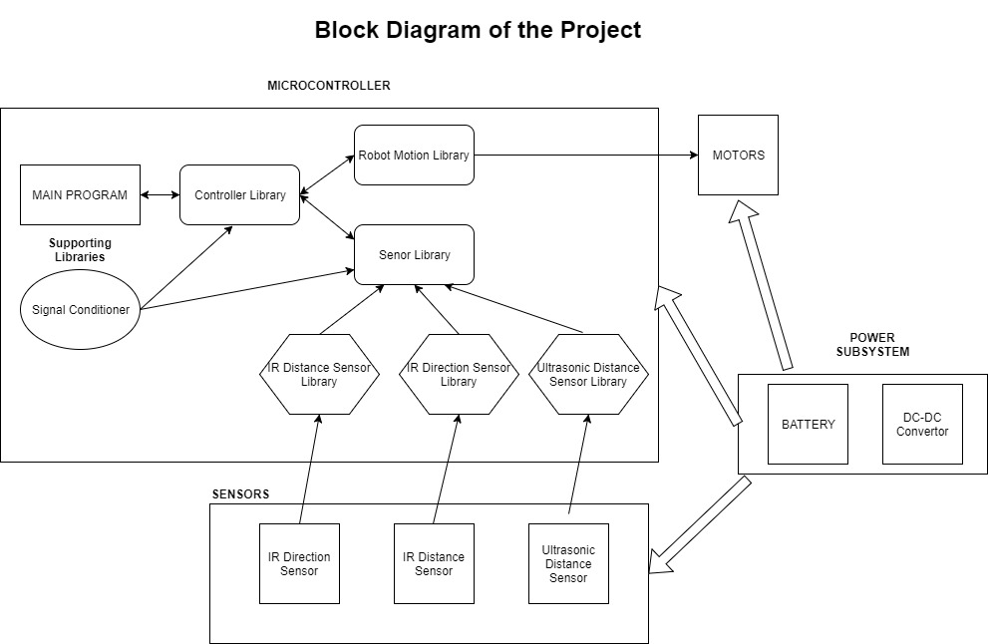

***Figure 1: The block diagram of the current system***

In Figure 1, the current state of the system is shown. Microcontroller runs the main program and libraries. The data taken from sensors are taken by sensor libraries and it is processed in controller library. Then the required information is sent to motors via Robot Motion Library. In addition, there is the power system which is composed of battery and DC-DC converter. It provides the energy to the microcontroller to run the system.

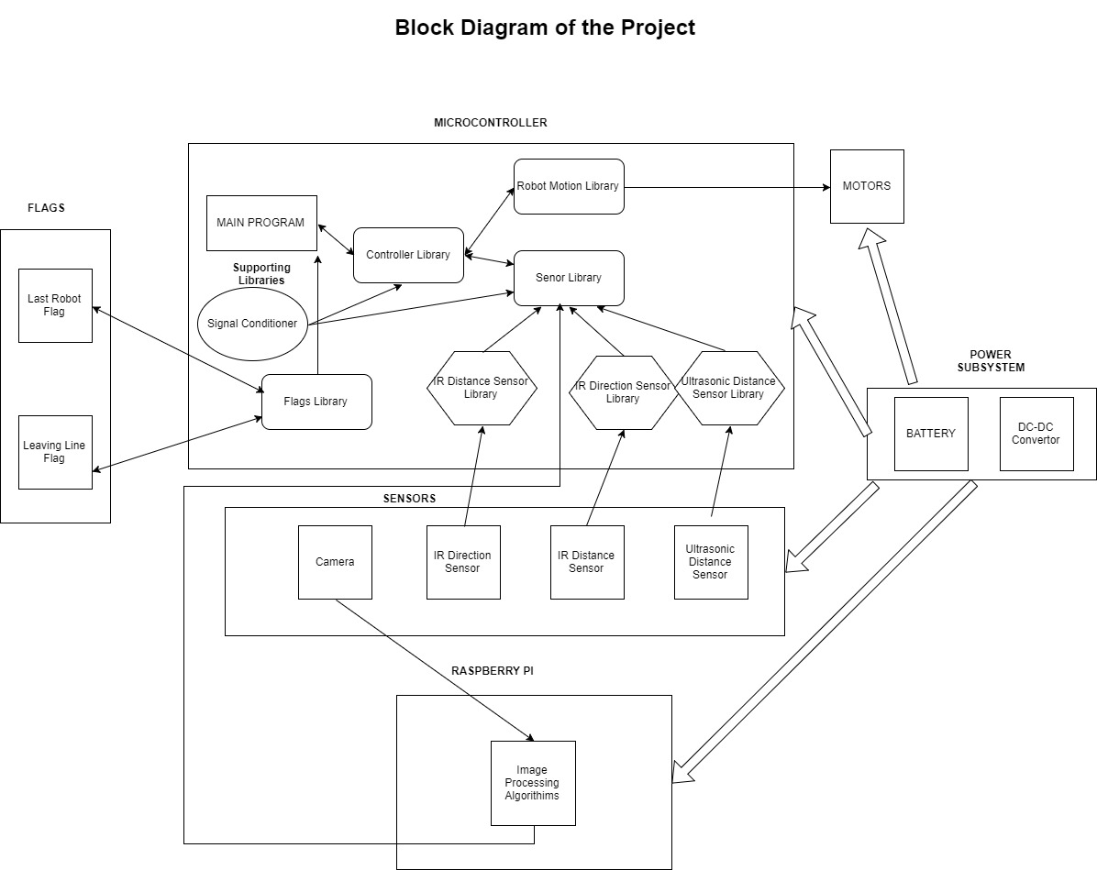

***Figure 2: The block diagram of the proposed system***

In Figure 2, it can be seen that in addition to the microcontroller we are using, we are going use a Raspberry Pi for image processing. There will also be a camera for the image processing. Furthermore, there will a flag library to detect and set the required flags.

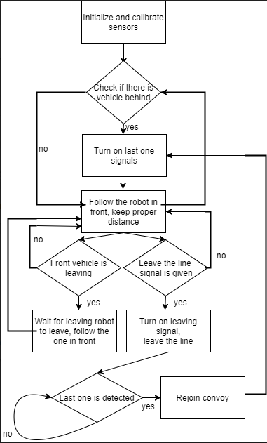

***Figure 3: The solution diagram for the system***

In Figure 3, the algorithm for the movement of the robot is explained in a simple manner with a flowchart.